Technician Customer Relationship
Training Manual

Section 1 - The Role of a Service Technician

Concept to be Explored | Learning Notes
What is the role of a service technician? | - The role of a technician is customer service.
 | - Every technician must understand we fix the customer first, then the technical aspects of the problem.
 | - The role of the technician is to be “THE BRAND” of a company for the customer – Brand = Trust and we need our customers trust to survive and prosper.
What does a technician really do? | - Creates image and establishes trust in a company and himself.
 | - Fixes customer mindset then the technical problems.
 | - Enhances/Damages reputation & brand.
What are a technician’s most important tools in order of priority? | - His brain.
 | - His mouth.
 | - His attitude.
 | - His demeanor.
 | - His image.
 | - His technical competence.
What are a customer’s home comfort needs? | - Quiet
 | - IAQ
 | - Comfort
 | - Air Movement
What are a customer’s wants? | - Best value lowest cost.
 | - Warranties
 | - Good Experience
 | - Trust
 | - Damage/Education
What are a customer’s desires? | - Trust
 | - Great System/Low Price
 | - Relationships
Why are you a service technician? | - Need the job.
 | - Only thing I can do.
 | - Good money.
Why do you sell things to customers? | - Company forces you into actions.
 | - Compensation is better.
 | - You like to sell.
 | - It’s common sense.
What is your personal value proposition to a company? | - Attitude
 | - Productive
 | - Fix the customers.
 | - Fix the problem.
 | - Mentor others.
 | - Can sell.
 | - Willing to change.
Your necessary skill sets to be successful and why? | - Organized
 | - Positive attitude.
 | - Learning is fun.
 | - Customer oriented.
 | - Team player.
 | - Hungry-Desire.

Section 2 – What Customer Service is in the 21st century?

Concept to be Explored | Learning Notes
What do customers expect? | - Friendly
 | - Positive Attitude
 | - Great Service
 | - Fair Price
 | - Explanation of Repair
 | - What do you have?
 | - Follow Up
How do you deliver what they expect and surpass their expectations? | - Systematic Approach
 | - The Perfect Service Call
 | - Be great customer relations.
 | - Make customer feel good.
 | - Respect their time.
 | - Be an educator not a seller.
How do you connect with a customer? | - Parked?
 | - Property respect.
 | - Where you stand.
 | - Visual impact.
 | - Eye contract.
 | - Smile
 | - Attitude – BL
 | - Extend hand.
 | - Proper handshake.
 | - Smell/Feel
 | - Greeting
 | - First 30 seconds.

What if they are difficult and aggressive? | - You are a mirror.
 | - Preparation
 | - Dispatch
 | - Control
 | - Listen
(cont.) What if they are difficult and aggressive? | - Empathize
 | - Ask questions.
 | - Confirm answers by restating – Checking.
 | - What do you want?
 | - State what you will do to resolve the problem.
 | - Confirm with them if this is acceptable.

Section 3 – The Fundamentals of Customer Service

Concept to be Explored | Learning Notes
What is the perfect service call? | - A process to EXCEED customer expectations.
 | - A sure fire way to increase your income.
 | - Happy customers.
 | - Better performance.
 | - Raises
 | - What do you have?
The steps break down into 10 areas of skills and knowledge:
- Pre-call
- Arrival
- The approach to the home.
- Contact
- The interview.
- Understanding humans.
- The plan for the customer.
- Diagnosis and treatment options.
- Executing the repairs.
- Debriefing & Completion

Why deliver this perfect call? | - Customer Retention
 | - Referrals
 | - Accessory sales opportunities.
 | - It’s more fun than unhappy calls.
 | - Career opportunities.
What products and services do  customers want and need? | - Demand service now.
 | - Maintenance (PTU’s)
 | - Accessories
 | - Upgrades
 | - Cut-Ins
 | - New systems.
 | - Indoor air quality remediation.
Why don’t they cooperate – Why do we have to educate (Sell)? | - Stupid?
 | - Cheap?
 | - Disorganized
 | - Ignorant
 | - No provider.
 | - Bad experiences.
How do you educate them properly so they will want to buy from your company? | - Systematically
 | - Process of questions.
 | - Listening skills.
 | - Proper conduct.
 | - Perfect service call creates trust.
Do customers buy or are they sold? | - Most buy / some sold?
 | - Control
 | - Logical vs. Emotional
 | - Buy on impulse.
 | - Trust
 | - Likeability
How do they buy? | - They want trust.
 | - They want best value.
 | - They want low risk.
(cont…) How do they buy? | - They want peace of mind.
 | - Feel special.
 | - Economics
What do they buy? | - Service Agreements
 | - PTU’s
- Accessories:
- Humidifiers
- Air Cleaners
- UV Lights
- IAQ Options:
- Air advice
- Duct cleaning
- Air duct remediation
 | - Upgrades
 | - Whole new system.
Why do they buy? | - Trust
 | - Peace of mind.
 | - Crisis

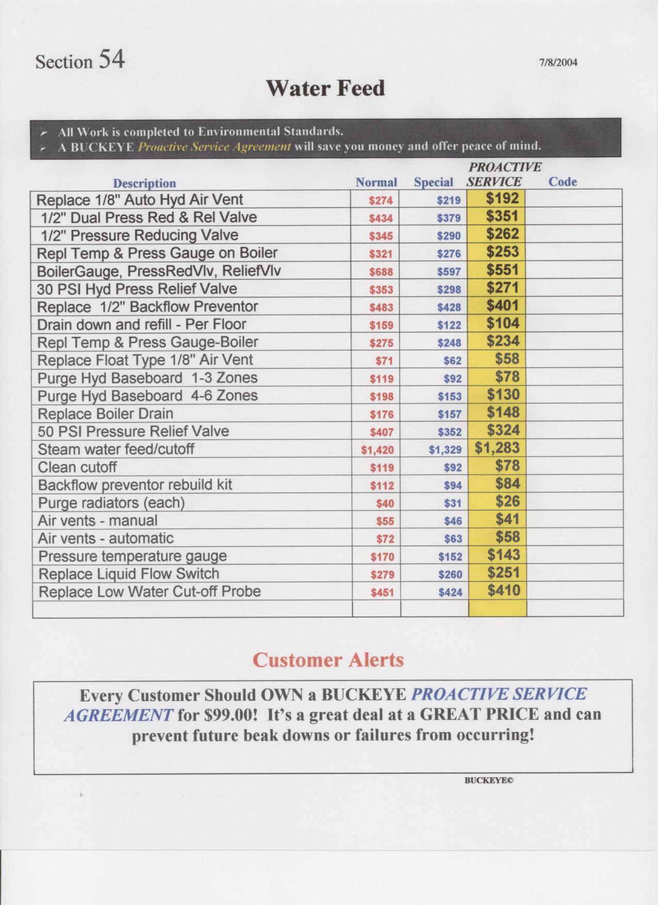
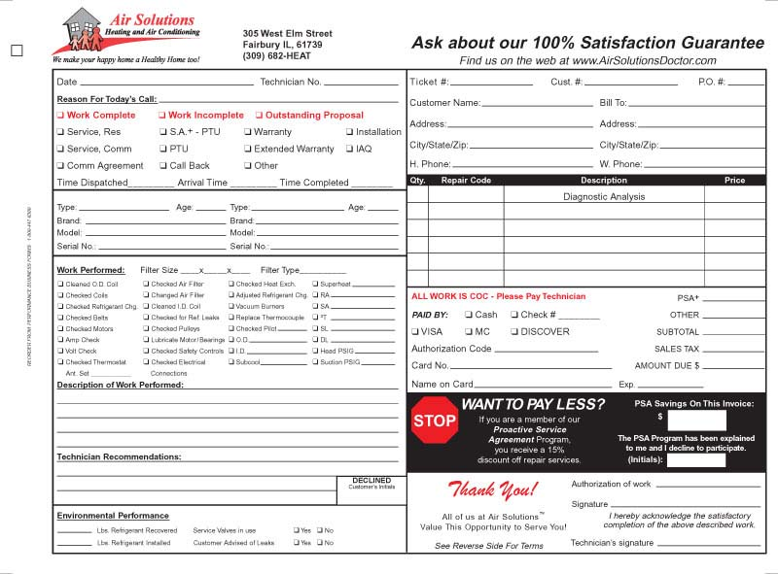

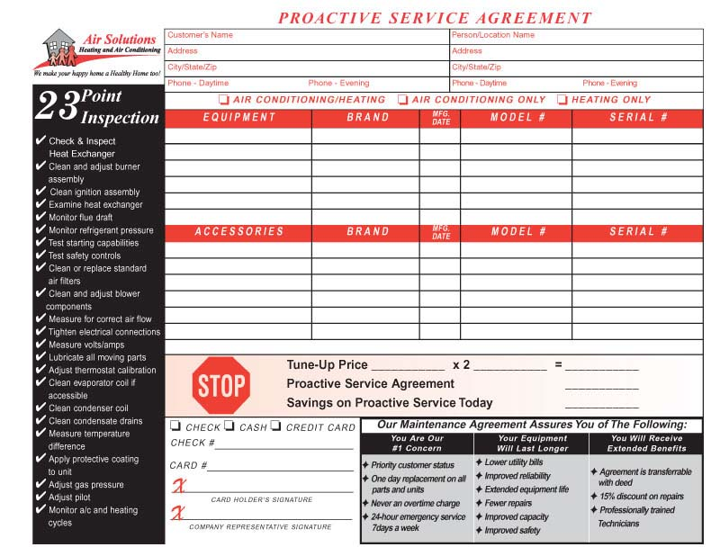
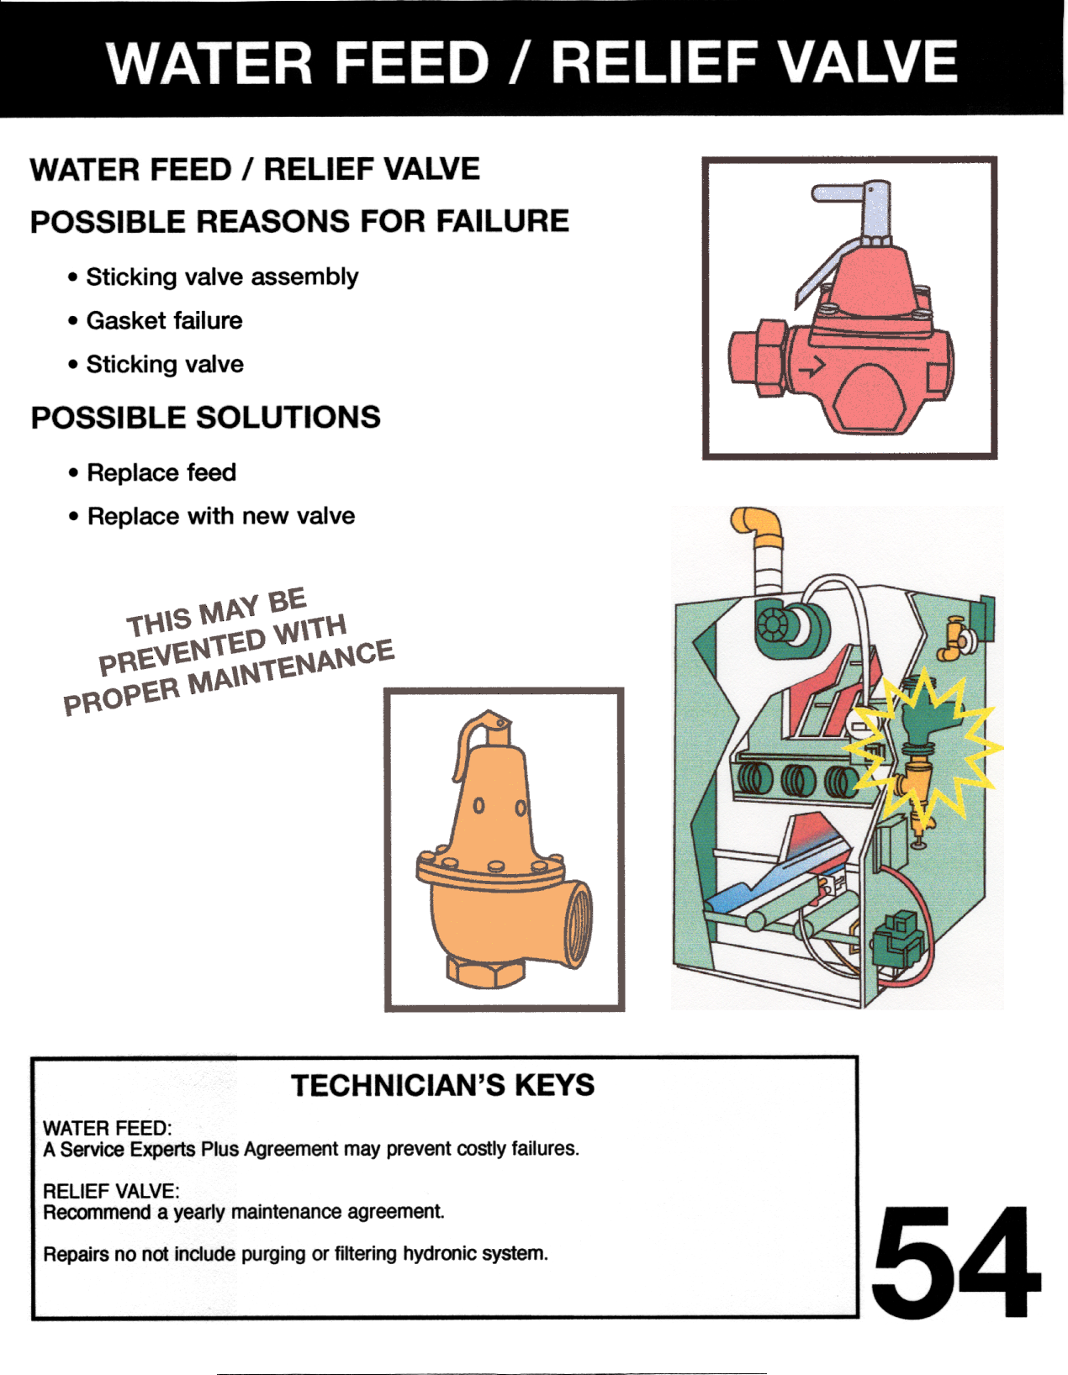

Section 4 – Improve your life by Improving your SKILLS

Concept to be Explored | Learning Notes
Attitude about learning – Lifetime learner! | - Attitude controls altitude.
 | - Attitude is a choice.
 | - Great attitude = Great job not the other way around.
 | - Make yourself valuable.
Get Serious about Self-Development! | - Personal skills development plan.
 | - Invest in your skills that make you valuable.
Learn the business of business and why you fit where you do, so you can achieve what you desire! | - Business has disciplines.
 | - Where do you fit and why?
 | - Understand what it takes to make the whole Thanksgiving dinner.
Set specific goals! | - Goals = Accountability
 | - Write them down.
 | - Develop a personal life plan.
 | - Learn personal skills and the rest will come easy.

